We are implementing attribution tracking within ActiveCampaign. It enables us to know how a given prospect came to us: Facebook ad, blast email, Google ad, etc.

If you build campaigns, from now on you must enable Google Analytics on each ActiveCampaign campaign you set up. That enables the attribution tracking.

## How To Do It

Google Analytics is enabled on a per campaign basis. **You must set the option on every single campaign.**

On the Campaign Summary page, you'll see the option to enable Google Analytics:

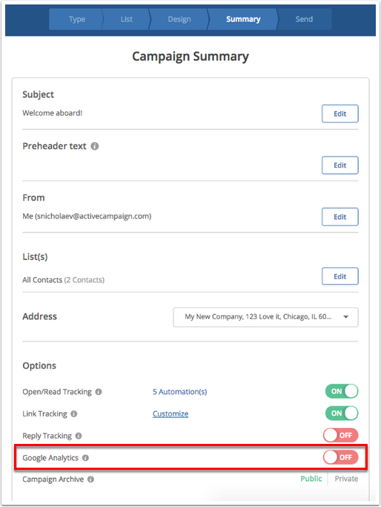

Click the red toggleto enable it. It should show as green “on”.

You'll be presented with a pop-up asking you to specify the Google Analytics Campaign Name. It should display the AC campaign name. No need to change it, just click "Done."

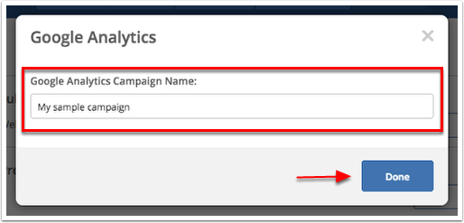

When you test the email, and specifically the links in the email, you will now see:

https://howtomanageasmalllawfirm.com/[PAGE-TO-LINK-TO-IS-HERE]/?utm_source=ActiveCampaign&utm_medium=email&utm_content=[SUBJECT LINE WILL BE HERE]&utm_campaign=[CAMPAIGN NAME WILL BE HERE]

The stuff after the “?” are the tracking parameters, aka, utm fields. ActiveCampaign will automatically add those parameters to every link in the email. You do not have to add them yourself.

Using the example above, you would simply set up your link to point to URL https://howtomanageasmalllawfirm.com/[PAGE-TO-LINK-TO-IS-HERE]/ as you normally do.